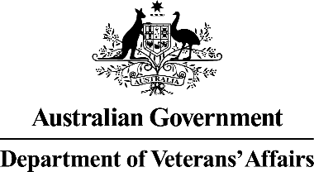

75th anniversary of National Service 1951-72
Service | Nationally broadcast commemorative service to mark the 75th anniversary of National Service 1951-1972
Date | Saturday 14 February 2026, 1030am AEDT preservice program commences  11:00am AEDT Official Service commences
Location | The Great Hall, Australia Parliament House, Canberra
Registration | Paper registrations to be completed and uploaded by membership organisations.

To support planning and delivery of the commemorative service marking the 75th anniversary of National Service 1951-72, attendees are asked to register using the Department of Veterans’ Affairs (DVA) online registration portal. Acknowledging there are members of the community that may not have access to the online registration portal, this registration form has been created to capture relevant details so a trusted colleague or a member of your local Ex-Service Organisation (ESO) community can provide assistance with registration.
Should you encounter technical difficulties or need assistance using the DVA online registration portal, please email COMMEMORATIVE.EVENTS@dva.gov.au and a member of the delivery team will be in touch.

75th anniversary of National Service 1951-72 registration form

1. | I have read and agree to the Privacy Collection Notice and DVA’s Privacy Policy:  - ☐ Yes  - ☐ No
2. | I am registering for:  - ☐ Myself  - ☐ On behalf of someone else
3. | Attendee’s details:  First Name:  Last Name:  Phone number:  Email address:
4b. |  | If Yes, please provide a brief description of your accessibility requirements below:
5. |  | Please select the option that best describes the attendee:  - ☐ They are a National Service Veteran  - ☐ They are a Widow or Widower of a National Service Veteran  - ☐ They are a family member or close friend of a National Service Veteran  - ☐ They are currently serving in the Australian Defence Force  ☐ They are a Veteran  ☐ Other (Please specify):
6. |  | If you are a National Service Veteran, we would like to hear your story. This may be published in promotional or educational material, or, used in ceremonial aspects of the Commemorative Program. Do you consent to DVA Media team to contacting you to discuss your story further?  - ☐ Yes  ☐ No

