**Queensland Chapter (Doug Oliver 4/71)**

**ANZAC Day March and Luncheon Brisbane 25 April 2025**

The Southeast Queensland Scheyvillians again marched behind the banner on ANZAC Day in Brisbane and afterwards retired to the Pig ‘N’ Whistle for lunch. The weather was lousy. Huey chucked it down, but that did not deter the hardy thirteen who marched, although continuing the declining trend of recent years: Keith Michael 2/71 out front, Peter Moody 2/67, Dave Griffiths 2/69, Robin Webcke 1/70 in the front rank, Dennis Simpson 3/69, Robin Apted 3/69, Don McNaught 4/69 in the second rank, Graham Wilson 1/72, Geoff Gardiner 4/69 in the third rank, John Knack 4/72, Peter Blackwood 4/69, Don Keyes 4/69 in the back rank. Geoff Daly 4/69 rode in the jeep.

Don Keyes 4/69, Dennis Simpson 3/69 (back), Geoff Gardiner 4/69 (front), Geoff Daly 4/69 and Robin Webcke 1/70

Two for the ladies: Carmel Daly with Geoff (left) and Melanie Keyes with Don (right)

**Monthly Luncheons**

Our monthly luncheons at the Pig ‘N’ Whistle in Brisbane continued in 2025 on 10 April, 8 May, 12 June and 10 July. Here we are at the July luncheon: (clockwise) Don Keyes 4/69, Dave (Griffo) Griffiths 2/69, Peter Blackwood 4/69 (having a dry July), Geoff Opray 1/65, Jim Box 1/66, Owen Williamson 4/70, Geoff Daly 4/69, Peter Moody 2/67, Doug Oliver 4/71. We were very pleased to welcome Geoff Opray, down from his home near Cairns for the milestone 60th anniversary reunion of his class 1/65 on the Sunshine Coast. As usual, the apologies were just as important as the attendees: Hugh Begbie 1/71, Jim Straker 1/66, Nick Israel 2/70, Geoff Pickering DS 69/70, Roman Ulanowicz 2/69, Mark Wallace 2/72, Terry O’Shea 4/69, Bob Sande 1/70, Gary Basford 3/68, John Robertson 1/71, Geoff Gardiner 4/69, Graham Wilson 1/72. See you all there one day.

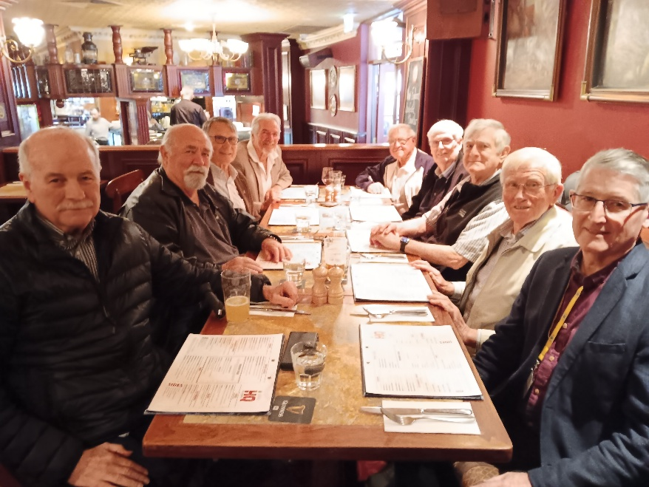

Queenslanders, put our 2025 monthly luncheons in your diary for the second Thursday of each month: 14 August, 11 September, 9 October, 13 November and our very special Christmas luncheon on 11 December. See you all there.

**What Scheyvillians Did, What Scheyvillians Do and Whatever Happened To**

**ANZAC Day in London**

Doug Oliver 4/71 commemorated ANZAC Day in London this year. It was the third in London: The first was with Terry Benjamin 1/69 in 2012; the second was with Don Keyes 4/69 and Neil Curnow 2/68 in 2016. Unfortunately, Don & Neil could not make it this year. Instead, Doug and his wife Terry were joined by their daughter Eliza-Jane, who lives in England (see the photo below, taken outside Westminster Abbey). It is a very special day: Dawn Service at Hyde Park Corner, the site of not only the Wellington Arch but also the Australian and New Zealand War Memorials; March and Wreath Laying Ceremony at the Cenotaph at 10:30 am; Midday Service at Westminster Abbey. In place of the traditional luncheon following the march in Australia, Doug, his wife and daughter had their own ANZAC Day luncheon in London. The day was cool, fine and only partly cloudy. Doug and his wife were in England on a two month home exchange with a lovely English couple who live in Lincolnshire. There was time to spend with their daughter and catch up with friends. Doug and Terry later took a short holiday on the continent, visiting Amsterdam and Brussels. It was Doug’s 18th trip to the UK.

