Scheyvillians,

The latest edition of The Scheyvillian is now available for your perusal.

This edition of The Scheyvillian is published in two formats.

The normal .pdf version is available from the OTU website home page,

[www.otu.asn.au](http://www.otu.asn.au)

scroll to the bottom of the page and click on

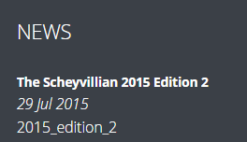

You do not need to log in as a member to access the magazine this way.

This issue is also available from the Scheyvillian archive.

To reach this you need to log in using your Surname and Regimental Number.

The Archive is found under “the Association” tab of the top menu bar.

This edition is also published via the ISSUU website.

Access is via this link:

<http://issuu.com/otuassociation/docs/2015_edition_2>

Initially the magazine appears as a thumbnail, which enlarges when downloaded.

The following controls are available:

 this enlarges or reduces the image size,

 this displays the pages across the bottom of the screen enabling easy selection of a particular page;

  these toggle between full page and a reduced page size;

 this displays as single or double page spreads;

Use the top arrows to flip pages left or right, and the bottom arrows to go the first or last pages;

 in full page mode, use this icon to download the magazine to save on your computer or to print.

The downside of this free display, is that other magazines published in this way are featured, either at the bottom of the page, or as a side bar in full page mode.

If you do not like the intrusion of these other publications, the .pdf version, available in the normal way are ad free.

Regards,

Roger Nation

Webmaster